**University of Michigan – Dearborn**

**Department of Computer and Information Science**

**CIS 150L – Fall 2014**

Lab 7

Srinivas Simhan

10/27/14

**Table of Content**

1. Question 1 3
   1. Screenshot 3
   2. Source Code 3
   3. Question 3
2. Question 2 4
   1. Screenshot 4
   2. Source Code 4
   3. Question 4
3. Question 3 5
   1. Screenshot 5
   2. Source Code 5
   3. Follow the 3 6
4. **Question 1**
   1. **Screenshot**

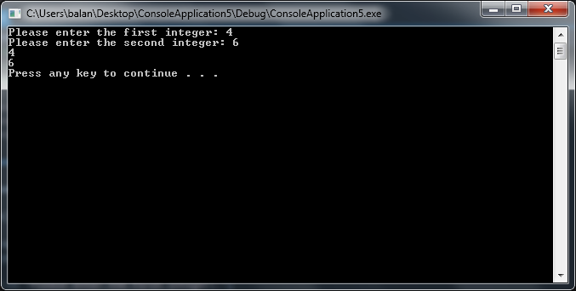

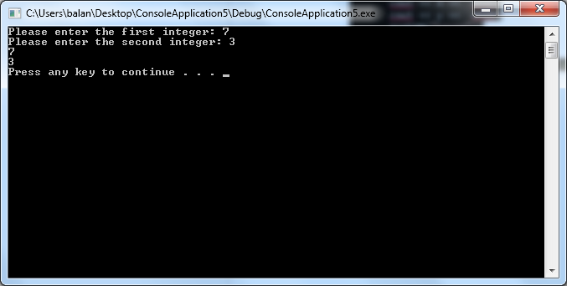

* 1. **Source Code**

//Purpose: Number Switch (It switches the order of the two integers provided.)

//Author: Srinivas Simhan

//Creation Date: 10/27/2014

//Last Modification Date: 10/27/2014

#include <iostream>

#include <cmath>

#include <string>

using namespace std;

void doIt(int&, int&);

int main()

{

int x, y, Answer;

cout << "Enter the 1st integer : ";

cin >> x;

cout << "Enter the 2nd integer : ";

cin >> y;

doIt(x, y);

cout << x << endl;

cout << y << endl;

system("pause");

return 0;

}

void doIt(int& a, int& b) // Please note the & symbol

{

int t;

t = a;

a = b;

b = t;

}

* 1. **Question (What does the function doIt perform?)**

It switches the order of the two integers provided.

1. **Question 2**

**2.1 Screenshot**

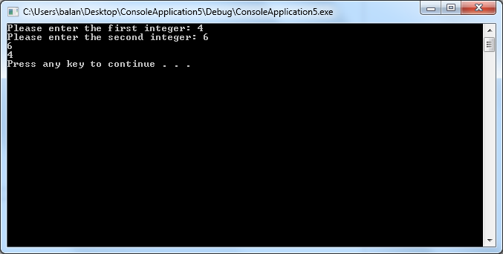

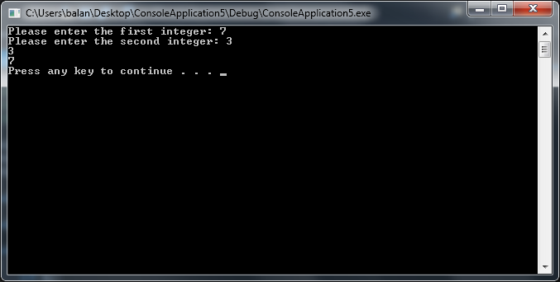

**2.2. Source Code**

//Purpose: Number List (The numbers stay in order.)

//Author: Srinivas Simhan

//Creation Date: 10/27/2014

//Last Modification Date: 10/27/2014

#include <iostream>

#include <cmath>

#include <string>

using namespace std;

void doSomething(int, int);

int main()

{

int x, y, Answer;

cout << "Enter the 1st integer : ";

cin >> x;

cout << "Enter the 2nd integer : ";

cin >> y;

doSomething(x, y);

cout << x << endl;

cout << y << endl;

system("pause");

return 0;

}

void doSomething(int a, int b) // Please note the & symbol

{

int t;

t = a;

a = b;

b = t;

}

1. **2.3 Question** (Compare the results displayed here with the ones displayed in Exercise 1. Why are they different?)

Exercise 2 outputs the numbers in the opposite order than what is given in Exercise 1. They are different because of the order the numbers are displayed.

1. **Question 3**
   1. **Screenshot**

**0:** 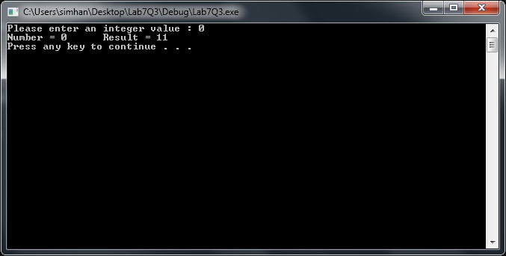

**1:** 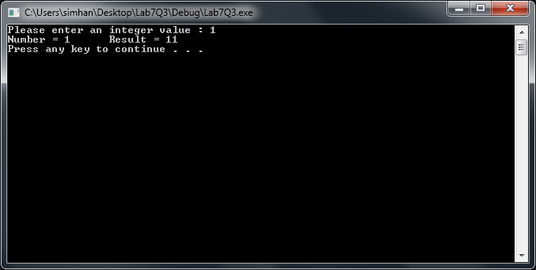

**2:** 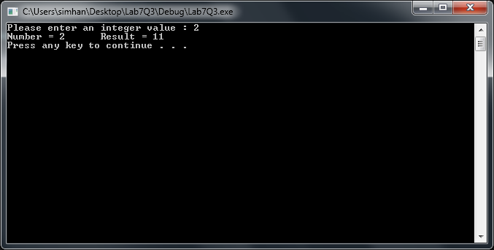

**3:** 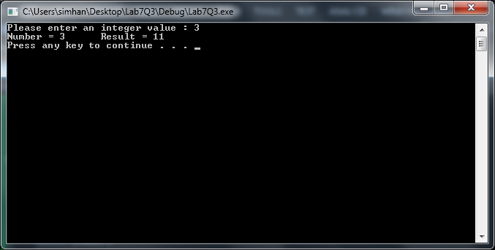

**4:** 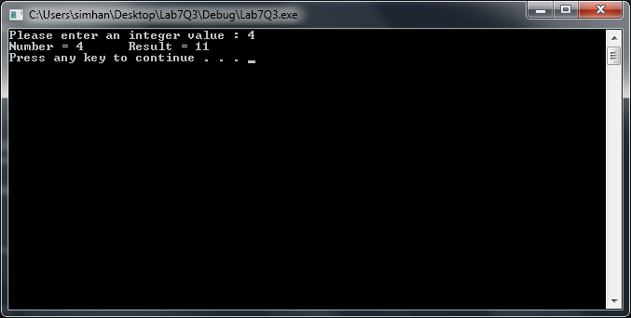

**10:** 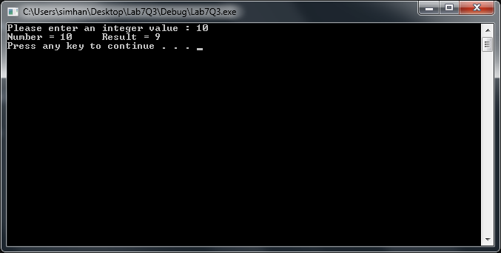

**20:** 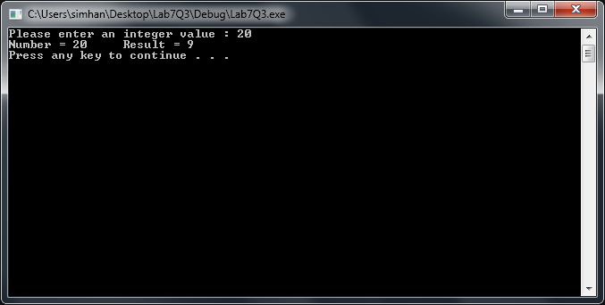

* 1. **Source Code**

//Purpose: Switch Case Number Modifier

//Author: Srinivas Simhan

//Creation Date: 10/27/2014

//Last Modification Date: 10/27/2014

#include <iostream>

#include <cmath>

#include <string>

using namespace std;

int main()

{

int number, result = 10;

cout << "Please enter an integer value : ";

cin >> number;

switch (number)

{

case 0:

case 1:

result++;

break;

case 2:

case 3:

result++;

break;

case 4:

result++;

break;

default:

result--;

break;

}

cout << "The result is : " << result << endl;

system("pause");

return 0;

}

* 1. **Follow the 3:**

**1)**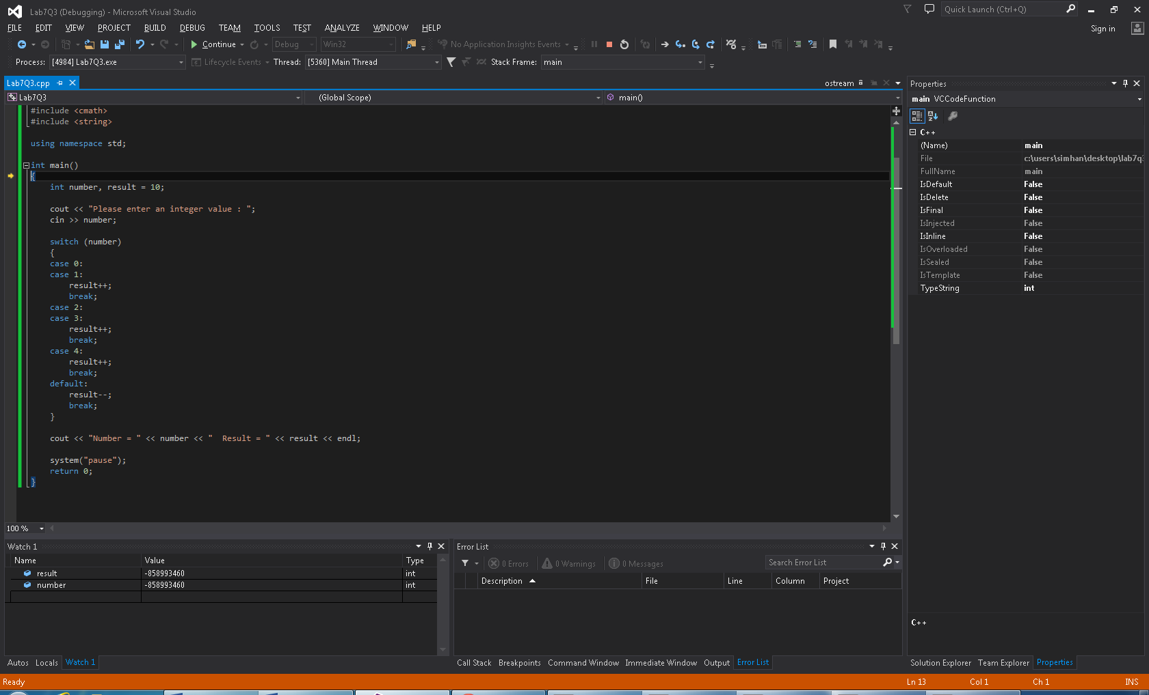

**2)**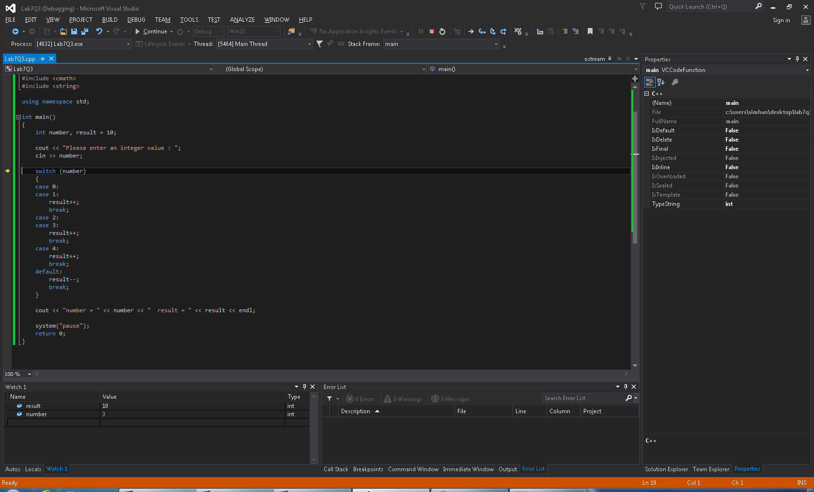

**3)**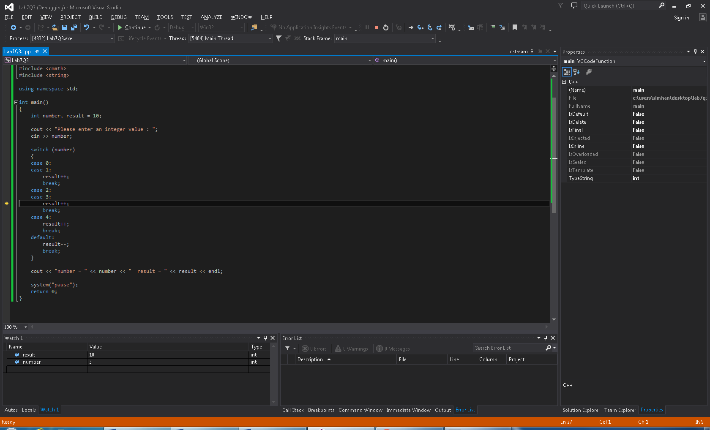

**4)**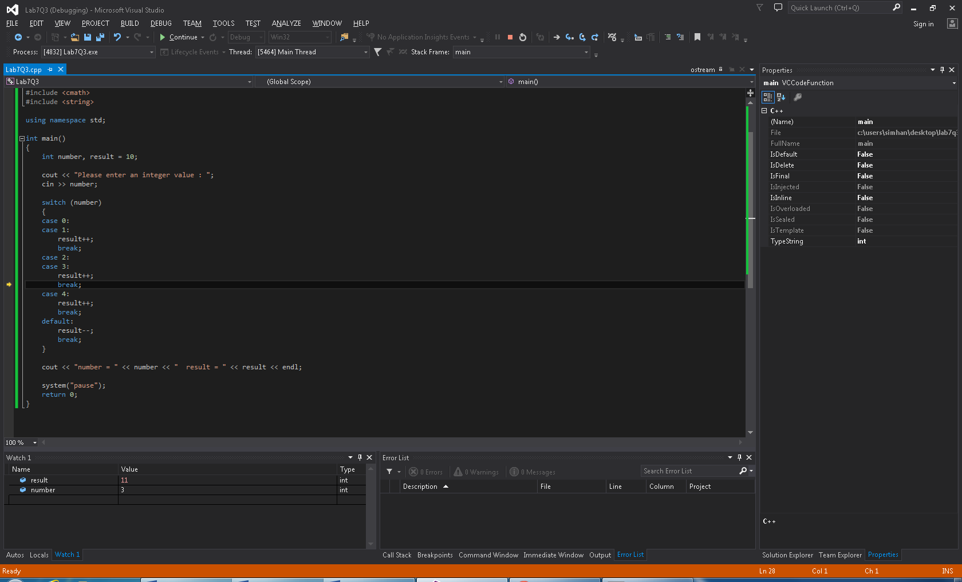

**5)**